Data source: imf.org

Imported as a table using URL

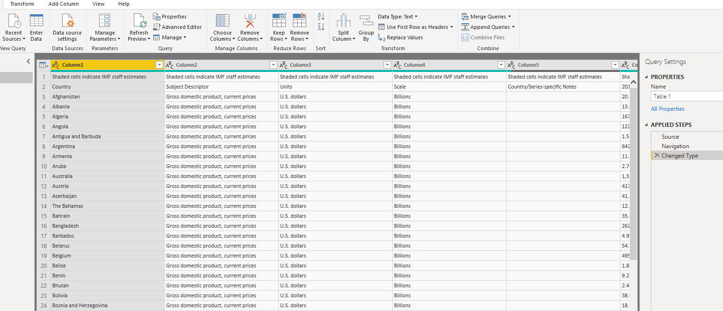 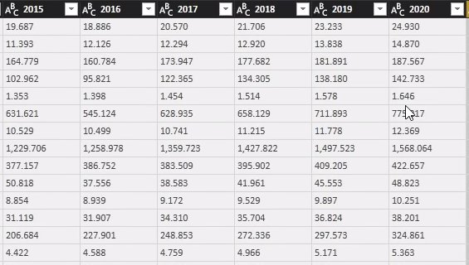

Edits made between views:

* Removed first row
* Made (new) first row the column names
* Removed empty columns
* transformed all year columns and made them into a single column using unpivot column(s)
* renamed newly created columns (year and GDP)
* removed any null attributes

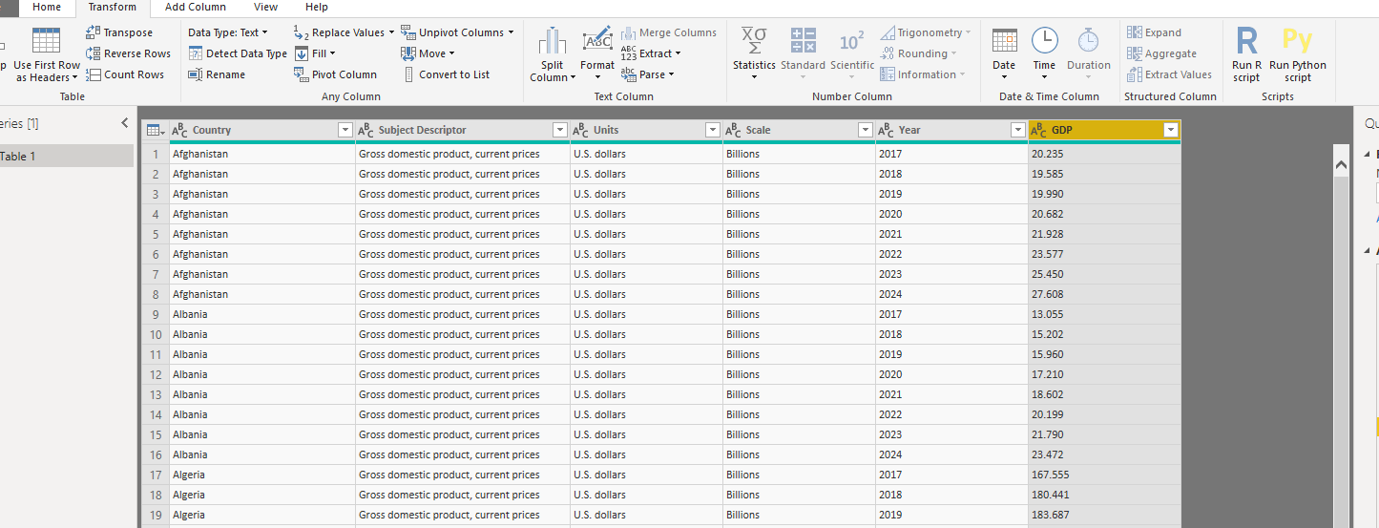

* changed data types:
  + year 🡪 number
  + GDP 🡪 decimal

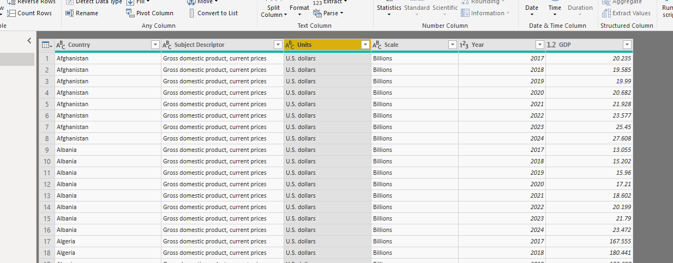

* Clean and Apply
* Changed category of country column to aid in visualization later on

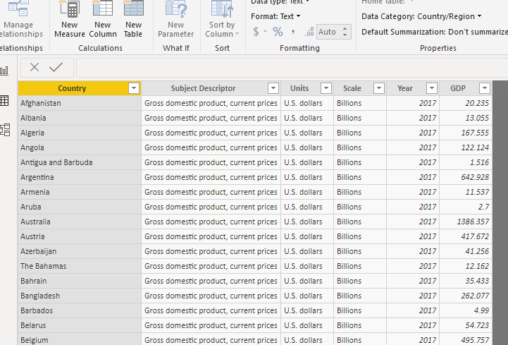

Create visualization (messy version) via drag and drop from the Fields to Visualizations tab

* GDP 🡪 value
* Year 🡪 axis
* Country 🡪 legend
* Filter top 15 countries

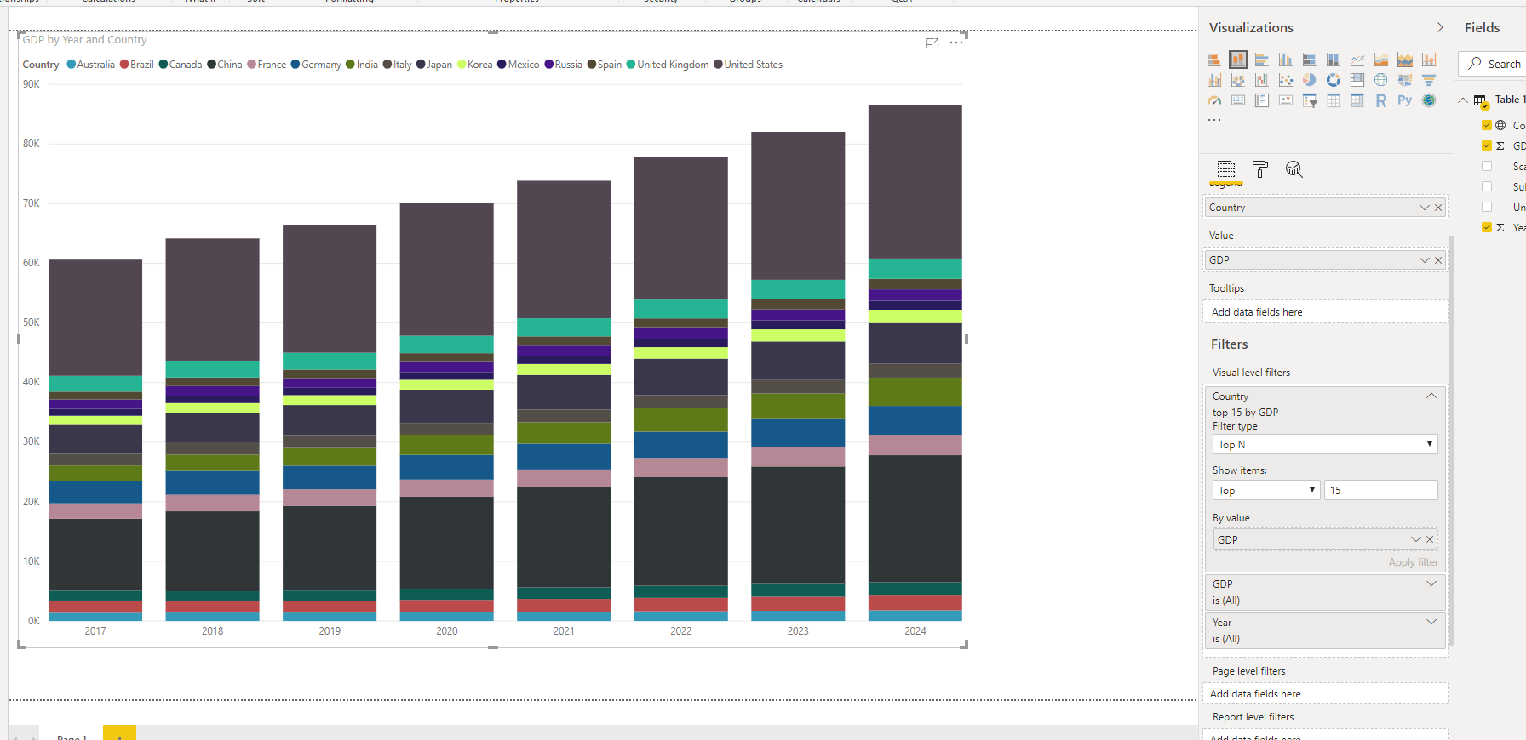

Change view to map and add labels

Though the sizes of many circles are very close, this infographic shows simply portrays the GDP of each country relative the others in the top 15.

